Hong Kong Diploma of Secondary Education
Examination 2020
Information and Communication Technology
(Coursework)

Option D: Software Development
Title: ABC System

Candidate ID No: A1234567 (5D99)

Contents

Chapter 1 Introduction 2
1.1 Background 2
1.2 Objectives 2
Chapter 2 Design of Solution 3
2.1 Brief Description 4
2.2 Refinement of Problem 5
2.3 Input Data File Formats 6
2.4 Output Report Format 9
Chapter 3 Implementation 13
3.1 Brief Description 13
3.2 Data Structures 14
3.3 Procedures in the Program 16
3.4 Program Coding 18
3.5 Program Execution 19
Chapter 4 Testing & Evaluation 22
4.1 Brief Description 22
4.2 Testing and Evaluation Plan 23
4.3 Internal Testing 24
4.4 Self-Evaluation 29
4.5 External Testing and Evaluation 29
Chapter 5 Conclusion & Discussion 33
5.1 Pros and cons of my Program 33
5.2 Future Improvement 33
5.3 Self-Reflection 33
Chapter 6 Reference and Acknowledgement 36
Appendices 37
Appendix 1 – Program Code (after Testing & Evaluation) 37
Appendix 2 - Working schedule 38

Chapter 1 Introduction

1.1 Background
[Type here ….]
Hints:
- Description of the problem and situation (use your own words)
  - Why do you study this problem?
    - Refer to the question:
An inter-school ICT competition, in the form of multiple-choice questions, ......
Imagine you are a programmer. You are going to develop a computer program to.......
    - Don’t just say that “this is a compulsory coursework in HKDSE - ICT Option D”

Remark:
- This report template is for the following Project Title
Project Title: Multiple-Choice Analysis Report
An inter-school ICT competition, in the form of multiple-choice questions, has been organised. The answer sheets for participants will be read by using an Optical Mark Recognition (OMR) system, and the options selected were converted into a text file.
Imagine you are a programmer. You are going to develop a computer program to read all raw text-based data and produce a detailed analysis report on the competition. The analysis report should include:
- Total number of participants, total number of participating schools and total number of participant(s) from each participating school
- Winners of individual awards and school awards
- Question analysis, such as the percentage correct for each question
Candidates are required to write a program to generate the analysis report. The coursework should:
- Describe the required plain text data files, including the keys of the multiple-choice questions and their format
- Define the competition regulations, such as individual awards and school awards
- Display a clear analysis report
Candidates should be aware of the reusability of the program design and justify the use of any data structures and algorithms in the implementation.

Chapter 2 Design of Solution
(> 5 pages)

2.1 Brief Description
[Type here ….]
Hints:
  - Give a brief description on what you are going to do.
- State the assumptions on the problem
Example
  - In this Chapter, I will design the program based on the functions I proposed in Chapter 1.
  - I will design:
- the overall structure of the program by refining the problem
- the formats of the data files for storing the answers of the participants and the answer keys
- the format of the report file for storing the analysis report
- ............ etc.
  - I will assume that
- ……
- ……
Hints:
- State the assumptions on the problem
- Must each participant belong to a school?
- Assumption on the maximum number of participating schools
- Maximum and minimum number of participants from each school?
- Using the same set of questions for all participants or not?
- How many questions in a question set?
- Are all the questions of MC type?
- How many choices are there in one MC question?
- What are the choices? (e.g. A, B, C, D, E or I, II, III, IV, V, etc.)
- All questions carry equal mark OR different levels of questions have different scores?
- How many round(s) of competition for each participant?
- How many awards will be provided?
- Who will get the awards?
- ..... etc.

2.2 Refinement of Problem
[Type here ….]
Hints:
  - Divide the problem into some sub-problems.
  - Describe the structure of the whole system graphically (using structure chart)
  - Briefly describe each sub-problem.

Example
  - Just for reference. The following may not be the best design. You should design your own.
The problem can be broken down into the following sub-problems.

MC_Analysis
Show_Results
Read_data
_file
Read_Participant_Ans
Read_Ans_
Keys
Calculate_participant_score
Calculate_school_score
Calculate
_results
Find_Winners
Sort_participant
_scores
Sort_school
_scores
Find_individual
_winner
Find_school
_winner
Save_Report

Note:
  - The above structure chart is just a sample for reference. In your actual work, you may:
    - first sketch the structure on a paper,
    - then develop the program,
    - modify the structure if necessary
  - You should briefly describe each sub-problem.

Data Flow:
  - Describe the flow of data graphically (including the filenames) so that the files involved can be clearly seen.
MC_ANALYSIS
MCDATA.TXT
ANSKEY.TXT
REPORT.TXT

2.3 Input Data File Formats
[Type here ….]
Hints:
  - Should be consistent with the flow of data you described in previous section.
  - Describe the formats of the input data files, including the file(s) storing participants’ answers and the file of answer key.
  - State the naming convention of the data files.
  - Draw the file structures
  - Show sample data in the files

For example,
- File storing the Participants’ Answers:
  - One single file only
  - File name: inputted by user (e.g. MCDATA.TXT) (As discussed in Section 2.3.) Any constraints on filename (e.g. 8.3 filename for program running in DOS mode)
  - File type: plain text file
  - Data stored:
The data file stores the record of each participant, which includes the following information:
- School code of the participant (6 characters)
- Participant code (6 characters)
- Answers of the 50 questions (altogether 50 characters)
- Valid answers: ‘A’, ‘B’, C’, ‘D’, ‘E’
- Invalid / Null answers: ‘-‘
  - File structure:
Each line of the data file stores the record of one participant with the following format:

 | School Code | Participant Code | Answers of 50 MC questions
 | (6 characters) | (6 characters) | 50 characters in ‘A’, ‘B’, C’, ‘D’, ‘E’, ‘-‘
e.g. | sch001 | s01001 | A | C | A | C |  | E | D | A | E

- Sample file:

sch005s05003ABDCEDEEEBAEDAAEDEAABABDBCADBEABCDEADCDEECDEBBCDCC
sch008s08003CBBCCECDEABBECCADCABEACACEECEDBBCBBCEECADEABCEACCE
sch010s10010EBDDCAADEABDBACABCAEBDDECCDEDCCBEEAADCCDCEBEAAEBAA
sch005s05008DBCDDBEEACDAEADADDDBCCCECEBCBDBDCEBCEBEBDADBCECACD
sch001s01006DAECBCDCCEDADCEDECEAADABDDBBEECDEEDCBEEDACAACBEDEA
sch001s01002DEECEDDBEADEDDDEDADBEDAACECAEAEADEDABDBADDADCCBACE
sch005s05009DBBABCCBCEDBCECAEECDBABCEBAEECBDADBEBCEBADBEEDBDAB
sch008s08010EACCDCEACBACAAEBCBEAEECBBEDABAADDCBBBACEADABAEABEA
sch003s03002AEDCCADBAEBAEDCEDCDAABDAEEEDCCEDBBEABCCDDDEBEEBACC
sch001s01004DBEDCCDEACECADECDDAADEBCCBABBDEAEADEDBBEDBDCECADBA
sch004s04001BCBCDBDCDBCCDDDBBDBEBECDADCDAACCBCEBECEACAAEBCDEBB
MCDATA.TXT

Remark:
Other possible structures of MCDATA.TXT file:
sch001
s01001
A
C
A
C
.
.
.
.
E
sch001
s01002
D
E
E
.
.
.

.

Record of first participant

Record of first participant

- File storing Answer Key :
  - One single file only
  - File name: inputted by user (e.g. ANSKEY.TXT) (As discussed in Section 2.3.) Any constraints on filename (e.g. 8.3 filename for program running in DOS mode)
  - File type: plain text file
  - Data stored (for one question set only):
The data file stores one set of answer keys for the 50 MC questions. The answer keys consist of 50 characters in ‘A’, ‘B’, C’, ‘D’ or ‘E’.
  - File structure:
A single line of 50 characters in ‘A’, ‘B’, C’, ‘D’ or ‘E’.:
- Sample file:
ABDCCDECAEACCDACBBAECBACDCBAABABADECECDDEDABABACDC
ANSKEY.TXT

- Sample input screen on running the program
  - E.g.
Enter the file name of the Answer Keys: ANSKEY.TXT

Enter the file name of the Participants' Answers: MCDATA.TXT

2.4 Output Report Format
[Type here ….]
Hints:
  - Should be consistent with the flow of data you described in previous section.
  - Should be consistent with the output results you suggest in Chapter 2
  - Note the basic requirements of the questions (e.g. the total number of participants, total number of participating schools and total number of participant(s) from each participating school, winners of individual awards and school awards, question analysis (such as the percentage correct for each question)).
  - What results will be output on screen? Why? (Note: the display on screen is of limited size, not too much information can be displayed on one screen)
  - What results will be output to report file?
  - Design the layout of the output on screen.
  - Design the layout of the report in file

For example,
- Sample output results on screen
  - Results displayed:
- Individual awards (with scores):
- Champion (participant code, school code)
- 1st Runner-up (participant code, school code)
- 2nd Runner-up (participant code, school code)
- School awards (with school average scores):
- Champion (school code)
- 1st Runner-up (school code)
- 2nd Runner-up (school code)
- Total number of participants
- Total number of participating schools
- Overall School Results:
- school code,
- no. of participants from each school,
- school’s average score
- Percentage correct for each question
- Etc.

  - Sample layout:
<< Inter-School Mathematics Competition Results >>

Individual awards:
Champion (score: 44):
s08009
1st Runner-up (score: 19):
s05003
2nd Runner-up (score: 16):
s04008 s09010

School Awards:
Champion (score: 14.10):
sch008
1st Runner-up (score: 11.10):
sch005
2nd Runner-up (score: 10.00):
sch004 sch009

Total number of participants: 93

Total number of participating schools: 10

Total number of participant(s) from each participating school:
sch008: 10 sch005: 10 sch004: 9 sch009: 10 sch003: 8
sch010: 9 sch007: 8 sch006: 10 sch002: 9 sch001: 10

- Sample output results in Analysis Report file
  - One single report file only
  - File name: inputted by user (e.g. REPORT.TXT) (As discussed in Section 2.3.) Any constraints on filename (e.g. 8.3 filename for program running in DOS)
  - File type: plain text file
  - Results stored:
- Individual awards (with scores):
- Champion (participant code, school code)
- 1st Runner-up (participant code, school code)
- 2nd Runner-up (participant code, school code)
- School awards (with school average scores):
- Champion (school code)
- 1st Runner-up (school code)
- 2nd Runner-up (school code)
- Total number of participants
- Total number of participating schools
- Overall School Results:
- school code,
- no. of participants from each school,
- school’s average score
- Percentage correct for each question
- Etc.

  - Sample layout: (next page)

<< Inter-School Mathematics Competition >>
<< Multiple-Choice Analysis Report >>

*****************************************************

Individual Awards:
Champion (score: 44):
s08009
1st Runner-up (score: 19):
s05003
2nd Runner-up (score: 16):
s04008 s09010

******************************************************

School Awards:
Champion (score: 14.10):
sch008
1st Runner-up (score: 11.10):
sch005
2nd Runner-up (score: 10.00):
sch004 sch009

*****************************************************

Total number of participants: 93

Total number of participating schools: 10

Total number of participant(s) from each participating school:
sch008: 10 sch005: 10 sch004: 9 sch009: 10 sch003: 8
sch010: 9 sch007: 8 sch006: 10 sch002: 9 sch001: 10

School Results:
School Code No. of Participants Average Score
sch008 10 14.10
sch005 10 11.10
sch004 9 10.00
sch009 10 10.00
sch003 8 9.88
sch010 9 9.67
sch007 8 9.62
sch006 10 9.50
sch002 9 9.44
sch001 10 8.60

*****************************************************

Percentage correct for each question:
Q1 16.13% Q2 24.73% Q3 22.58% Q4 22.58% Q5 29.03%
Q6 19.35% Q7 24.73% Q8 16.13% Q9 17.20% Q10 24.73%
Q11 22.58% Q12 26.88% Q13 12.90% Q14 18.28% Q15 15.05%
Q16 18.28% Q17 20.43% Q18 12.90% Q19 24.73% Q20 17.20%
Q21 13.98% Q22 24.73% Q23 19.35% Q24 19.35% Q25 19.35%
Q26 17.20% Q27 15.05% Q28 19.35% Q29 17.20% Q30 18.28%
Q31 29.03% Q32 11.83% Q33 20.43% Q34 26.88% Q35 18.28%
Q36 20.43% Q37 18.28% Q38 30.11% Q39 17.20% Q40 16.13%
Q41 18.28% Q42 22.58% Q43 30.11% Q44 23.66% Q45 25.81%
Q46 21.51% Q47 24.73% Q48 19.35% Q49 16.13% Q50 21.51%
Q46 21.51% Q47 24.73% Q48 19.35% Q49 16.13% Q50 21.51%

Chapter 3 Implementation
(> 5 pages)

Hints:
  - You should construct your program and then write down the implementation details in this part.

3.1 Brief Description
[Type here ….]
Hints:
  - Give a brief description on what you are going to do.
Example
  - In this Chapter, I will discuss the implementation of the MC Analysis Program.
  - I will:
- determine the data structures that will be used in the program.
- describe the functions that will be performed by each procedure in the program.
- explain the main algorithms used in the program
- display some of the program codes
- display the user interface and analysis report.

3.2 Data Structures
[Type here ….]
Hints:
  - Describe the data structures (e.g. arrays) that will be used in your program. (You should state clearly whether you use 1-dimensional or 2-dimensional arrays.)
  - You should justify the use of any data structures.
- Explain the use of each data structure.
- Explain why do you use such data structure to store the data/results
  - Use examples to explain.

Example
The following parallel arrays will be used to store the school code, student code and student score of each participant:

stu_sch : array[1..maxrecno] of string[6];
stu_code : array[1..maxrecno] of string[6];
stu_score : array[1..maxrecno] of integer;

where maxrecno is a constant defined at the beginning of the program.

e.g. stud_sch[1], stu_code[1] and stu_score[1] will store the corresponding data of the first participant.

Questions to think:
- Is it necessary to use an array to store the MC answers of each participant that are read from the data file (e.g. MCDATA.TXT)? Why?
- What is/are the data structures for storing the answer keys read from the answer key file (ANSKEY.TXT)
- Consider the report / results you want to produce. What other data structures / arrays that you will define to store them? e.g.
- How to store the total number of participant(s) from each participating school?
- How to store the average score of each school?
- How to store the percentage correct for each question?
- Etc.
……………….

You may use diagram(s) to illustrate:
- E.g. In my program, ……
sch005s05003ABDCEDEEEBAEDAAEDEAABABDBCADBEABCDEADCDEECDEBBCDCC
sch008s08003CBBCCECDEABBECCADCABEACACEECEDBBCBBCEECADEABCEACCE
sch010s10010EBDDCAADEABDBACABCAEBDDECCDEDCCBEEAADCCDCEBEAAEBAA
sch005s05008DBCDDBEEACDAEADADDDBCCCECEBCBDBDCEBCEBEBDADBCECACD
sch001s01006DAECBCDCCEDADCEDECEAADABDDBBEECDEEDCBEEDACAACBEDEA
sch001s01002DEECEDDBEADEDDDEDADBEDAACECAEAEADEDABDBADDADCCBACE
sch005s05009DBBABCCBCEDBCECAEECDBABCEBAEECBDADBEBCEBADBEEDBDAB
sch008s08010EACCDCEACBACAAEBCBEAEECBBEDABAADDCBBBACEADABAEABEA
sch003s03002AEDCCADBAEBAEDCEDCDAABDAEEEDCCEDBBEABCCDDDEBEEBACC
sch001s01004DBEDCCDEACECADECDDAADEBCCBABBDEAEADEDBBEDBDCECADBA
sch004s04001BCBCDBDCDBCCDDDBBDBEBECDADCDAACCBCEBECEACAAEBCDEBBsch001s01007EBCCBBDADAAEACECCEBEDBCBEADDBAAADCBABCDADEDDBBADBC
sch001s01008BABBCECDEEACECBCDDDAEBDECECCBDACDAAAAEEBEDACDCDADB
sch001s01009CCCAEAEBCEDAAAECCCBCBBCBBCADDEACBDCADEBEAEEBAADDBD

MCDATA.TXT
stu_schsch005
ABDCCDECAEACCDACBBAECBACDCBAABABADECECDDEDABABACDC
ANSKEY.TXT
Check
stu_codes05003
stu_score19

3.3 Procedures in the Program
[Type here ….]
Hints:
  - List the procedures that you use in the program.
  - The procedures should be consistent with the program structure you design in Chapter 2.
  - Describe the purposes / uses of each procedure.
  - Explain the algorithm(s) that you use in the procedure to achieve the purposes.
  - You may display some of the program codes to illustrate.
  - You may also use flowchart to illustrate. Draw the flowchart by using the Drawing Tools in Word.

Example
According to the sub-problems in Section 2.2 of Chapter 2, the following procedures will be constructed in the program:
- Read_data_file
( Describe & explain the algorithms, use flowchart if necessary)
…………………………………….
……………………………………
  - . Read_Participant_Ans
( define procedure(s) within procedure, if necessary)
( Describe & explain the algorithms)…………………………………….
……………………………………………….
  - . Read_Ans_Keys
( Describe & explain the algorithms)…………………………………….
…………………………………………………
- Calculate_participant_score
( Describe & explain the algorithms)…………………………………….
……………………………………
- Calculate_school_score
( Describe & explain the algorithms)…………………………………….
……………………………………
- Find_Winners
( Describe & explain the algorithms)…………………………………….
………………………………………….
  - . Sort_participant_scores
( define procedure(s) within procedure, if necessary)
( Describe & explain the algorithms)…………………………………….
……………………………………………….
  - . Sort_school_scores
( define procedure(s) within procedure, if necessary)
( Describe & explain the algorithms)…………………………………….
……………………………………………….
  - . ……………………………………………….
……………………………………………….
- ……………………………………………………..
………………………………………………………….

3.4 Program Coding
[Type here ….]
Hints:
  - Briefly describe the process of program coding (writing).
- By using which programming language and tools (e.g. QPascal, Dev-Pascal, etc.)
- Writing the source program and then compile it into the object program (the executable program .exe)
  - What is the filename of the source program? (e.g. MCPROJ.PAS)
  - What is the filename of the object program? (e.g. MCPROJ.EXE)
  - ……………………
  - You may show some screenshots to illustrate.
  - Your complete program code should be placed in the Appendix Section. You should mention this. (e.g. Refer to Appendix 1 for the complete program code.)
Example
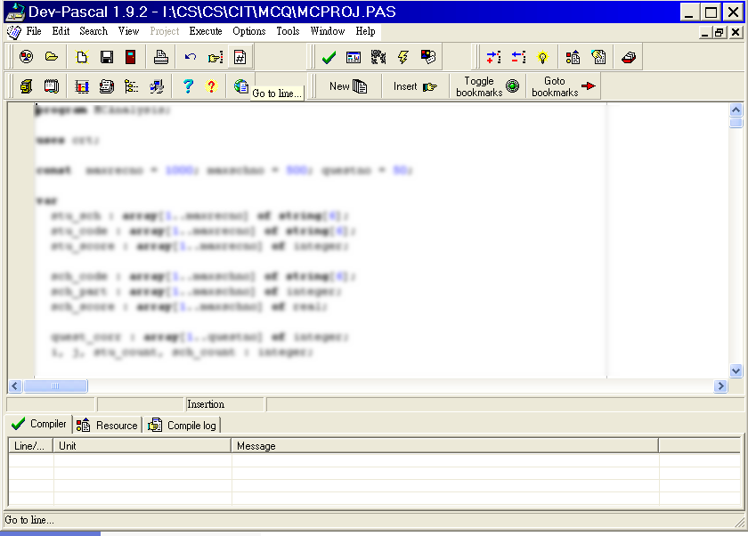
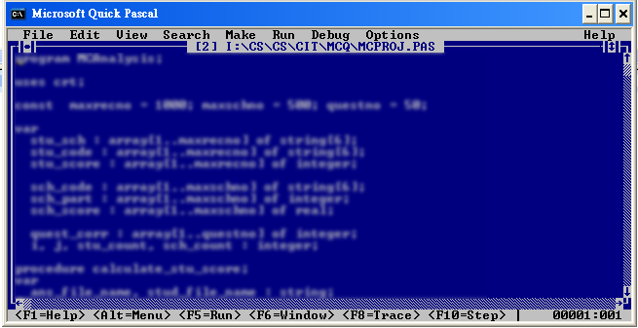

3.5 Program Execution
[Type here ….]
Hints:
  - Describe the steps in execution of program.
  - What data files should be prepared before execution? e.g.
- The text file storing the answer keys (ANSKEY.TXT)
- The text file storing the Participants’ Answers (MCDATA.TXT)
- Refer to Section 3.3
  - What file should be produced? (e.g. the report file REPORT.TXT)
  - You should capture some screenshots/pictures of the user interface from your program.
  - Briefly describe the screenshots.
  - The screenshots (with descriptions) should be arranged in proper order so that the flow of operation of your program can be shown.
  - You may consider this as a simple user guide for the user. You may construct a more detailed user guide in the Appendices of this report.
  - etc.
Example
- Program file: MCPROJ.EXE
- Data file to be prepare for input:
- The text file storing the answer keys: ANSKEY.TXT
- The text file storing the Participants’ Answers: MCDATA.TXT
- Indicate that the program file and data files should be put into the same folder / location before execution.
- Briefly explain that the files are prepared by MS Notepad for program testing.

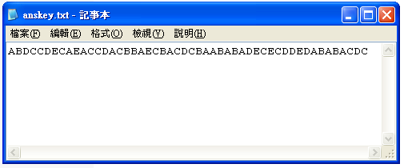
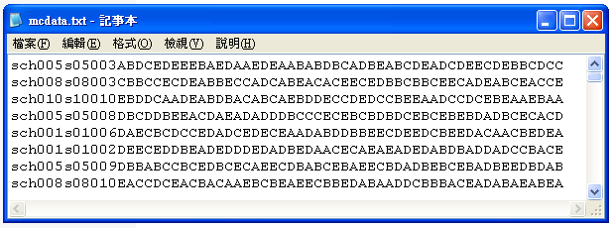

- User interface of the program (The input screen)
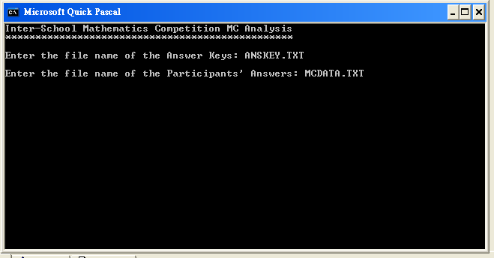
( Description …….. e.g. What should be inputted ? ..)

- Results displayed on screen
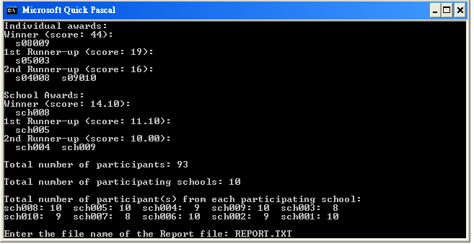
( Description ………..)
- Report file

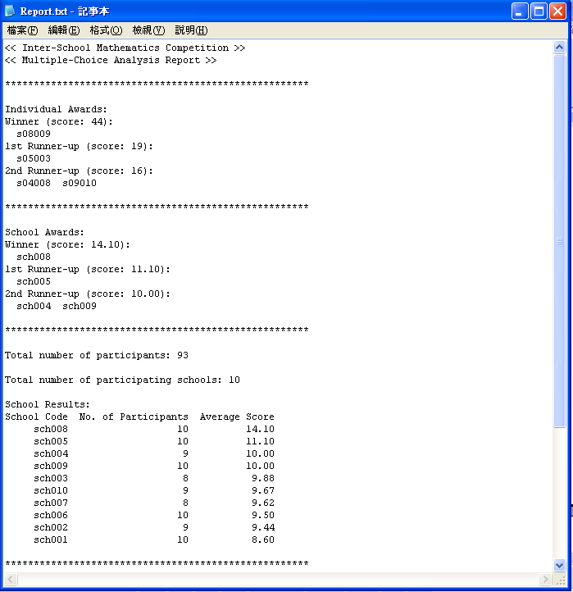
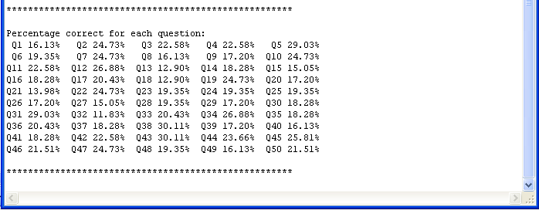

( Description ………..)

Chapter 4 Testing & Evaluation
( > 5 pages)

4.1 Brief Description
[Type here ….]
Hints:
- Briefly describe the purposes of program testing and evaluation, e.g.
  - to find out the bugs (logical and run-time errors) in the program,
  - to check whether the program can achieve its purposes,
  - to see whether the program is user-friendly, ......., etc.
  - to debug and improve the program based on the testing and evaluation results

4.2 Testing and Evaluation Plan
[Type here ….]
Hints:
  - Briefly describe your testing and evaluation plan, i.e. describe how to carry out testing and evaluation.
Example
The program will be tested and evaluated according to the following plan:
- Internal testing and evaluation / Tested and evaluated by me (the programmer):
- The program will be tested intensively by me – the programmer
- I will prepare different test cases to test the program thoroughly
- The test cases include some correct input data (from files & keyboard) with known results for checking the correctness of the program, some incorrect input data to see whether the program can handle invalid input reasonably, etc.
- I will also evaluate the programs according to its user-friendless, performance, flexibility for future development, reusability of program codes, etc.
- External testing and evaluation / Tested and evaluated by users:
- I will invite some (e.g. 10) targeted users/my classmates/friends to test and evaluate the program. E.g.
  - I will upload the object program (the .exe file) and some sample data files onto a share folder in our school e-learning platform to let some users to try.
  - I will upload the corresponding files to my blog / Web site and ask my friends to try
  - etc.
- The users are invited to report the bugs they find and give their comments and suggestions on my program
I will try to modify the program according to the reported bugs and suggestions. The new version of program after making modifications will be shown in Appendix 1.

4.3 Internal Testing
[Type here ….]
Hints:
  - The test is done by the programmer (yourself)
  - You should design different test cases, each focuses on different features of the program
  - For each test case, you should
- describe the purpose of the test case
- describe the input (should be consistent with the purpose)
- describe the expected output / results
- describe the actual output / results. You may use screenshot(s)
- state the conclusion of the test (pass or not).
  - If the test is not passed, suggest the modification(s) that should be made.
  - Modify the program accordingly or explain why you are not able to modify it (e.g. out of your ability).

Example

Test case 1
Purpose: | To check the correctness of the output results on screen and in the report file by using normal input data
Input: | Normal answer keys file and participants’ answers file.  All the filenames are inputted correctly during execution of program
Expected Output: | The expected results (e.g. scores of individual awards and school awards and number of participants from each school, etc.) are calculated by using MS Excel.
Actual Output: | All actual results are the same as the expected results.
Test Result: | Pass / No bugs found
Follow-up Action: | Nil

Screenshots (if any)

Test case 2
Purpose: | To test the program for the case when there are some invalid answers (other than ‘A’, ‘B’, ‘C’, ‘D’, ‘E’) in the participants’ answers file
Input: | Normal answer keys file.  Some answers in participants’ answers file are changed to characters other than ‘A’, ‘B’, ‘C’, ‘D’ or ‘E’.
Expected Output: | The invalid answers should be treated as incorrect answers.  The expected results (e.g. scores of individual awards and school awards and number of participants from each school, etc.) are calculated by using MS Excel.
Actual Output: | All actual results are the same as the expected results.
Test Result: | Pass / No bugs found
Follow-up Action: | Nil

Screenshots (if any)
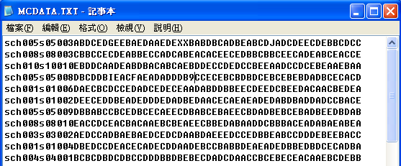

Test case ....
Purpose: | To test the program for the case when there are some missing answers in the participants’ answers file
Input: | Normal answer keys file.  Some answers in participants’ answers file are missing, e.g. less than 50 answers for some students, or some answers are empty.
Expected Output: | The missing answers should be treated as incorrect answers.  The expected results (e.g. scores of individual awards and school awards and number of participants from each school, etc.) are calculated by using MS Excel.
Actual Output: | All actual results are the same as the expected results.
Test Result: | Pass / No bugs found
Follow-up Action: | Nil

Screenshots (if any)
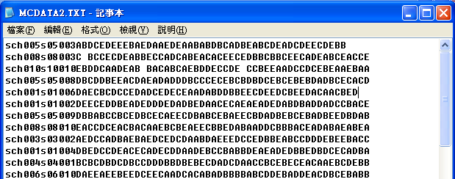
Test case .....
Purpose: | To test the program for the case when the filename of the answer keys file has not been inputted during execution
Input: | When the user is asked to enter the filename of the answer keys file, he presses <Enter> to skip the input
Expected Output: | The program should stop and ask the user to input the filename again.
Actual Output: | The program did not ask the user to input the answer keys filename again, but it continued to ask for the filename of the participants’ answers file
Test Result: | The program did not response as expected
Follow-up Action: | Modify the program so that it will ask the user to input the filename of the answer keys again if the filename has not been inputted. Repeat-loop is used.

Origin response of program
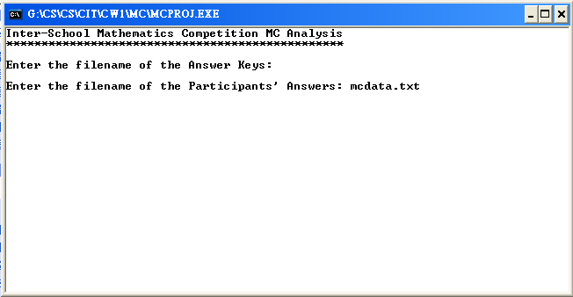

Response of program after modification
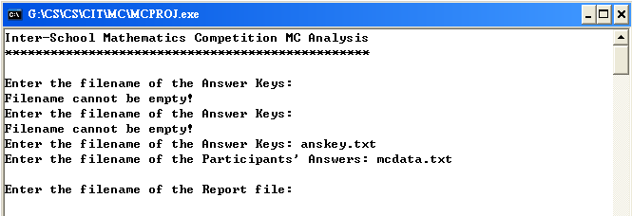
Repeat asking for the filename of answer keys until a filename is inputted
Test case .....
Purpose: | To test the program for the case when the answer keys file does not exist
Input: | When the user is asked to enter the filename of the answer keys file, a filename of an non-existed file is inputted
Expected Output: | The program should stop and ask the user to input the correct filename again.
Actual Output: | The program terminated after the incorrect filename was inputted
Test Result: | The program did not response as expected
Follow-up Action: | Modify the program to handle the case of filename. / Though the program did not response as expected, it is out of your ability to improve the program.

Screenshots (if any)
………

Test case .....
…………………………………………

Test case .....
…………………………………………

Test case .....
…………………………………………

Test case .....
…………………………………………

4.4 Self-Evaluation
[Type here ….]
Hints:
- Point out any good features and shortcomings of your program
- In additional to the basic functions/features, you may also consider the user-friendless, performance, flexibility for future development, reusability of program codes, etc.

4.5 External Testing and Evaluation
[Type here ….]
Hints:
  - Describe how to carry out the external testing and evaluation
  - Refer to your testing and evaluation plan in pervious section
  - E.g. upload the object program (the .exe file) and some sample data files onto a share folder in our school e-learning platform to let some users to try.
  - You may design a Program Testing and Evaluation Form for users to give their comments and feedbacks
  - E.g. (a sample on next page). Please design your own Program Testing and Evaluation Form.

Testing and Evaluation Form

Please help to evaluate the program: Multiple-Choice Analysis. Thanks!

Instruction:
- Please execute the program according to the instructions in the ReadMe.txt file in the program folder.

Report on Bugs:
No. | Description of errors

Program Evaluation:
Please answer the following questions by circling the numbers on the right hand side.
 |  | Rating
 |  | Agree Average Disagree
1. | The program is user-friendly | 5 | 4 | 3 | 2 | 1
2. | The design of the input screen is good | 5 | 4 | 3 | 2 | 1
3. | The format of the report is good | 5 | 4 | 3 | 2 | 1
4. | The ……. functions are useful | 5 | 4 | 3 | 2 | 1

Which features you like most?
_______________________________________________________________________________

What other functions should be provided by the program?
_______________________________________________________________________________
_______________________________________________________________________________
_______________________________________________________________________________

Other Suggestions
_______________________________________________________________________________
_______________________________________________________________________________
_______________________________________________________________________________

Evaluator’s Name: _______________________ Date: ____________________
Summary of the evaluation
Summarize the evaluation results from users.
E.g.
 |  | Average score
1. | The program is user-friendly | 3.5
2. | The design of the input screen is good | 2
3. | The format of the report is good | 1
4. | The ……. functions are useful | 4

Describe any follow-up actions.
- E.g. Some users reflect that too much information is displayed on the output screen
Follow-up Action:
- A menu is designed to let users to choose the output results they want:
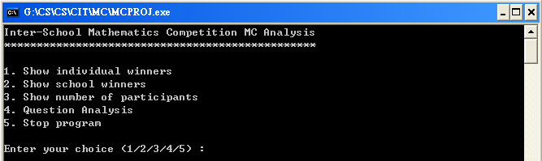

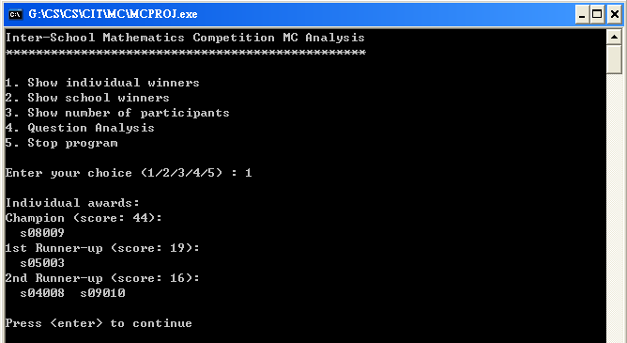

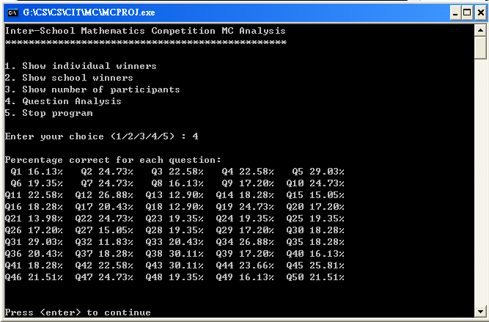

Chapter 5 Conclusion & Discussion
(10%, >= 2 pages)

5.1 Pros and cons of my Program
[Type here ….]

5.2 Future Improvement
[Type here ….]

5.3 Self-Reflection
[Type here ….]

Example:
The following example is extracted from other report (not for this project, just for reference)

Pros and cons of my ebook
I have spent lots of time in doing this ebook. From planning, making and testing, there are lots of ideas put in it and I tried to make it perfect. Although it is corrected lots of times, still there are something not really convenient for readers, which I cannot correct. There is showing my ebook’s pros and cons.
My ebook is a tour guide to Kyoto. So, Japan’s culture and Kyoto local characteristics are mainly recommended in this ebook. Readers can learn more about Kyoto and Japan not only though their eyes viewing words, graphics, but also though their ears hearing the sounds and video. After reading this ebook, I think some of the readers would want to take a trip to Kyoto and see whether Kyoto is look like that or not. Also, I chose the soft music because I hope readers can enjoy reading in a comfortable environment. So, playing these music may make readers relax and calm down to take a look of Kyoto. That is my ebook can give readers to have a chance knowing more about traditional Japan and culture. Not just only focus on Japan’s clothes, fashion and games. Also, the links provided, I had been finding them for a long time. These links are useful and interesting. Readers can save time to search for those web sites. The information in this book also I had spent time collecting the data from many places. All these are useful for readers’ trip to Kyoto.
Still there are some not really convenient for readers. First, is the ebook loading is quite slow. I have changed into a faster speed’s way, however the loading speed still not very fast. If I made it faster, then those beautiful and convenient styles of my ebook would be lost. I think readers would not really mind it is not fast, but for some of the readers whose computers do not have powerful CPU. Their loading time may be longer. I am really sorry about this.
I hope I can do more perfect next time, in order to make my ebook smoother and suitable for different kinds of people.

Future Improvement
In future, I really hope I can add more information into my ebook. So, that this Kyoto trip can be more perfect. I would try to add in different special places in Kyoto, so that my ebook can suitable for different kinds of readers. For example, I will find out some places can provide traditional Japanese’s food. Readers can go Kyoto and try whether they are delicious or not. In order to shorter the loading time, I would try more different kinds of method. Also, I will add in more animation so that the ebook can have a funnier impression. Not only students, but also other aged people would to travel Kyoto. So, I hope to provide some other ebook versions for adults or even children. Give them a chance to see know about Kyoto.

Self-Reflection
In making this ebook, I have learnt more Kyoto also Japan’s culture. Most important is the incentive learning and keeping our country’s culture. Japanese do not think learning history is a waste of time. Know more about our country is important to show you are belonging to your country.
Also, I have learnt how to format a book, collect useful data, ways to get information. These are useful for me. Furthermore, I learnt how to create a web page smoothly and creating a theme for a web page frameset.

Chapter 6 Reference and Acknowledgement
From Internet websites
1. http://www.useful.com.hk/~abc
2. .....
.....
From books
1. .....

Acknowledgement
1. .....

Appendices

Appendix 1 – Program Code (after Testing & Evaluation)
program MCAnalysis;
………………………………………………..

Appendix 2 - Working schedule
Date | Event

Gantt Chart
